**Bug report 1**

**Sumarry: Tab Kursevi - Subtitles are showing in the introduction video though subtitle function is turned off**

**Steps to reproduce:**

1. Go to the navigation bar and hover over Kursevi

2. On the new modal dialog pick UI UX Kurs 2.0

3. Scroll down to the first introduction video and start video

4. On the right button side of video there is icon with text CC and click on this icon.

**Actuall result:** When user go to the tab Kursevi and open introduction video , he will see subtitle turn on even button CC is turn off. On the playing video the title is visible even it is turn off in the configuration.

**Expected:** When user go to the tab Kursevi, subtitle on video should not be visible if it turn of on CC icon settings.

**Attachments:**

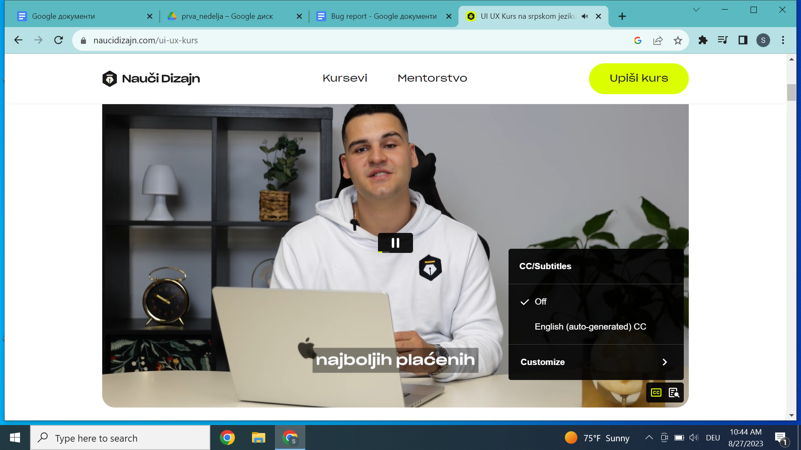

**Bug report 2**

**Summary: Tab Kursevi - Subtitle in English do not follow the speech of the presenter and it is not correctly translated.**

**Steps to reproduce:**

1. Go to the navigation bar and mouse hover tab Kursevi

2. On the new dialog pick UI UX Kurs 2.0

3. Scroll down to the first introduction video and start video

4. On the right button CC turn on English subtitle

**Actual result:** When user go to the tab Kursevi and first presentation video and if user activate English subtitle, in that case subtitle is shown but does not follow speech of presenter and translation is wrong.

**Expected:** User go to the tab Kursevi and when he scrol down to the first presentation video and activates English subtitles, after that action translation should follow presenter speech and translated text should be correct.

**Attachments:**

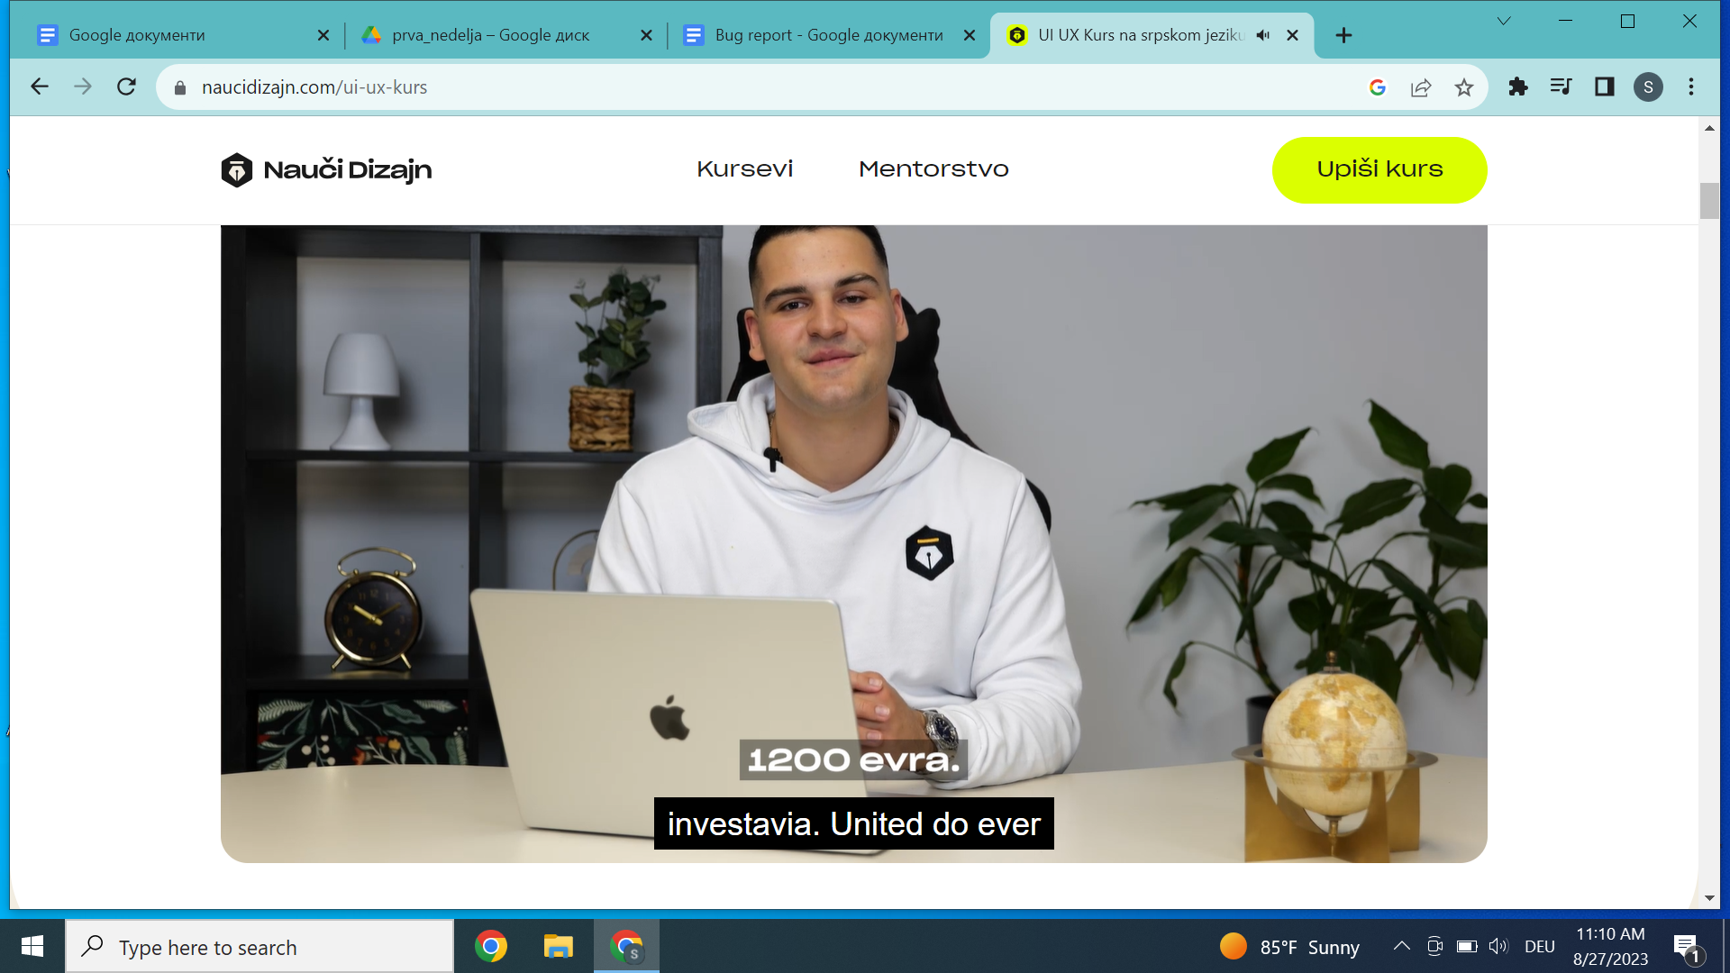

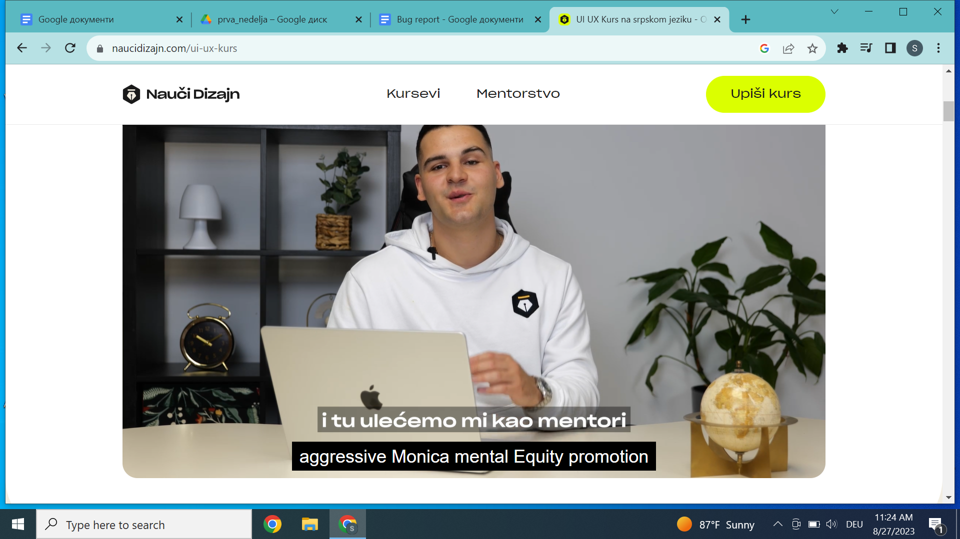

**Bug report 3**

**Summary:** Tab Kursevi - UI UX 2.0 course , when user click button “Upisi kurs” , that action does not lead to the correct place in the page.

**Steps to reproduce:**

1. Go to the navigation bar and mouse hover tab Kursevi

2. On the new dialog pick UI UX Kurs 2.0

3. Click button in the navigation bar “Upisi kurs”

**Actual result:** When user go to the tab Kursevi - UI UX 2.0 and click on the button “Upisi kurs”, the action does not lead us to the correct place “Cene paketa”.

**Expected:** Click on the tab Kursevi - UI UX 2.0 and after click button on the navigation bar “Upisi kurs”, it should navigate user to the “Cene paketa”.

**Attachments:**

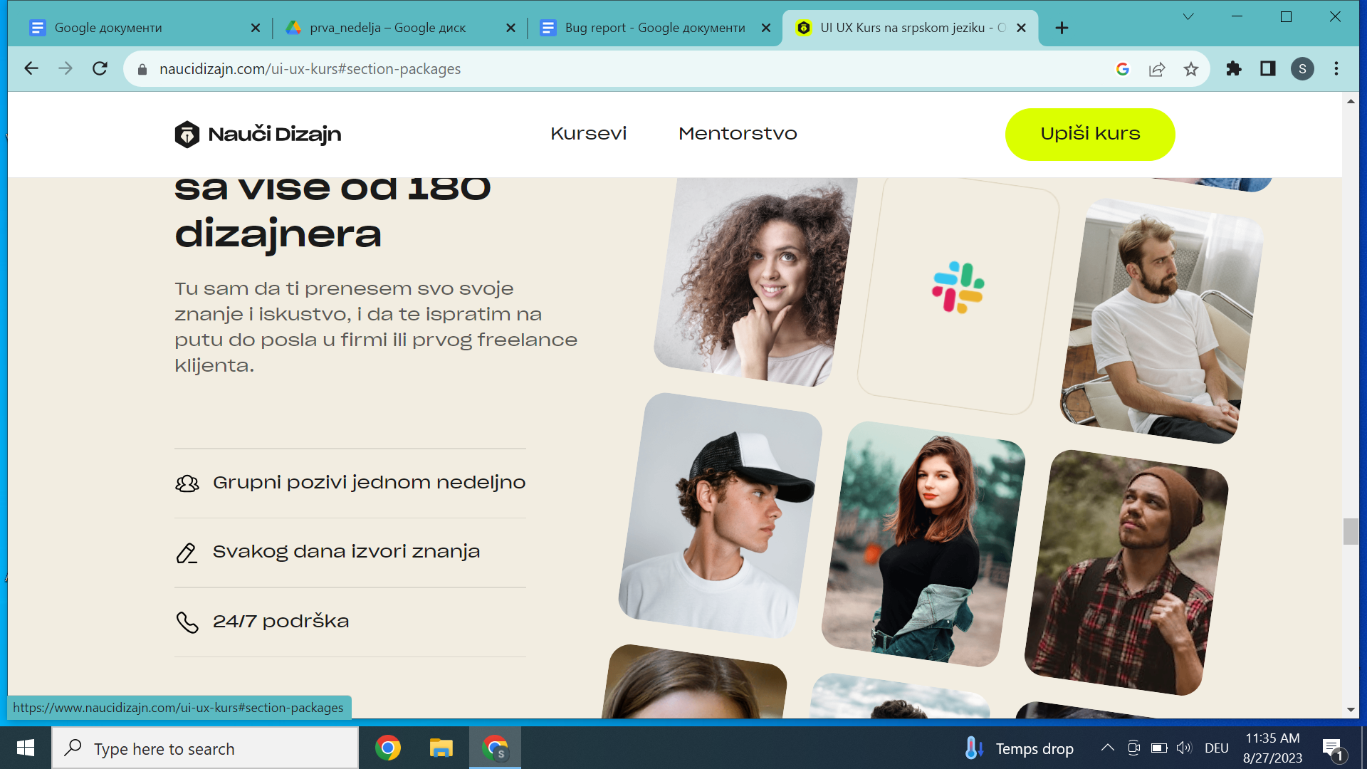

**Bug report 4**

**Summary:** Tab Kursevi - After effects course , in the navigation bar there is no button “Upisi kurs” , there is only button “Vidi kurseve”

**Steps to reproduce:**

1. Go to the navigation bar and mouse hover tab Kursevi

2. On the new modal dialog pick cours After effects

3. On the navigation bar the user can not notice button “Upisi kurs”

**Actual result:** When user go to the tab Kursevi and choose After effects course, after in the navigation bar instead button “Upisi kurs” there is button “Vidi kurseve” .

**Expected:** Click on the tab Kursevi and choose After effects course, after in the navigation bar button “Upisi kurs” should be visible .

**Attachments:**

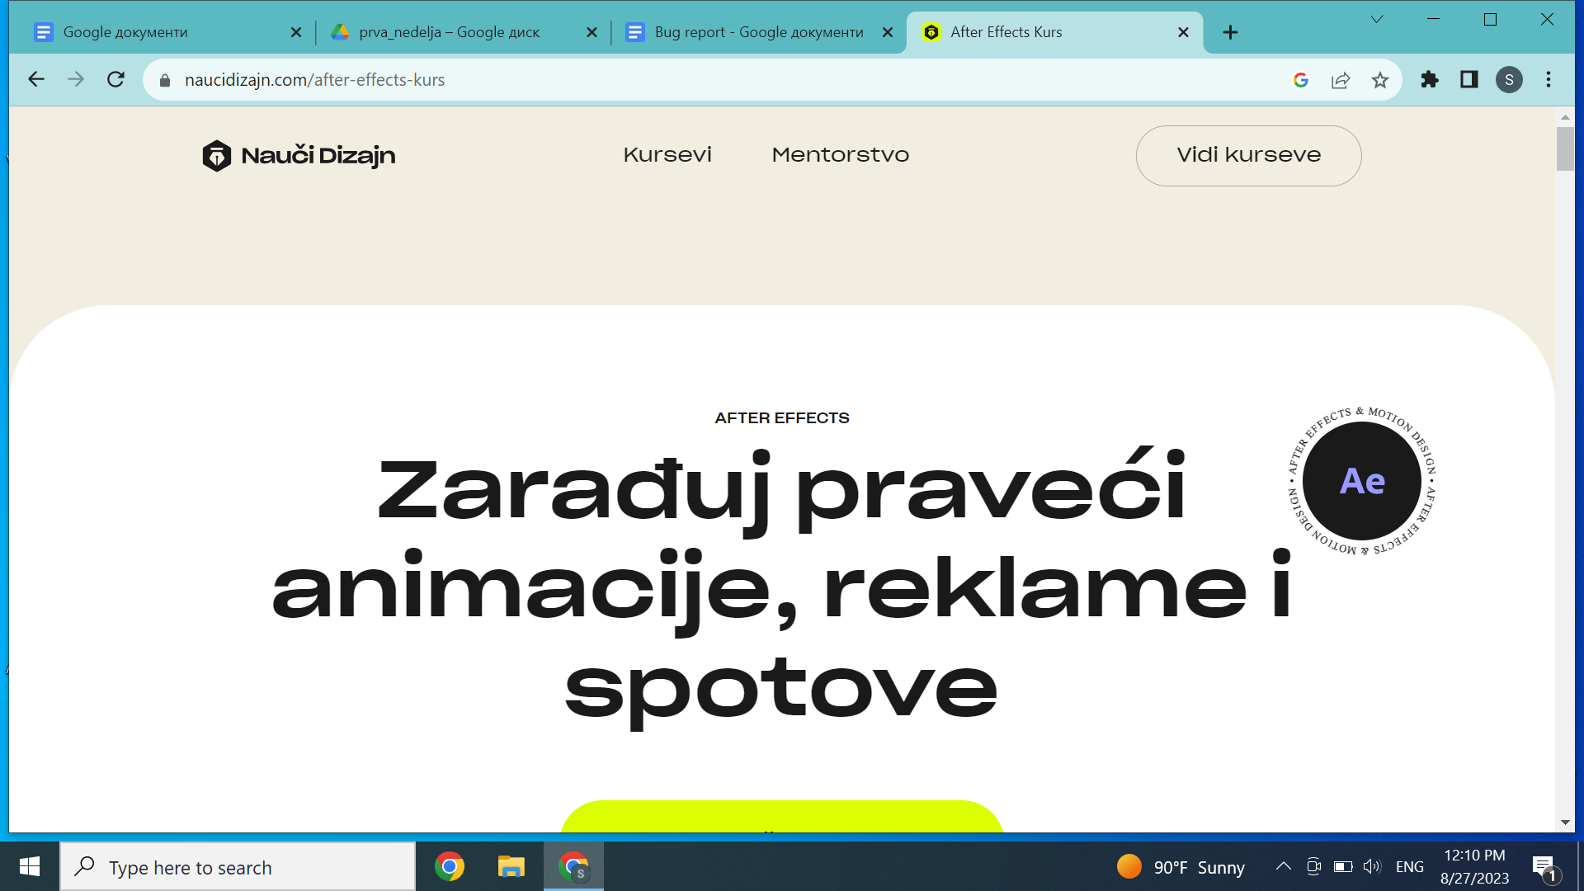

**Bug report 5**

**Summary:** Tab Kursevi - Webflow course , in the navigation bar there is no button “Upisi kurs” , there is only button “Vidi kurseve”.

**Steps to reproduce:**

1. Go to the navigation bar and mouse hover tab Kursevi

2. On the new modal dialog pick cours Weblow

3. On the navigation bar the user can not notice button “Upisi kurs”

**Actual result:** When user go to the tab Kursevi and choose Webflow course, after in the navigation bar Instead button “Upisi kurs” user can see only button “Vidi kurseve”

**Expected:** Click on the tab Kursevi and choose Webflow course, after in the navigation bar button “Upisi kurs” should be visible .

**Attachments:**

